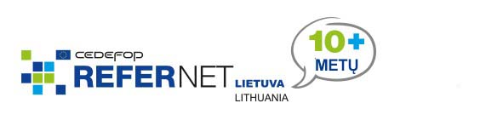

Lithuania: work experience for general education students

Lithuanian general education schools are increasingly organising work experience ‘tasters’ for their students. Vocational activation (profesinis veiklinimas) is considered to be a priority measure in career education and vocational guidance, during which students are acquainted with various employment sectors, career possibilities and occupational characteristics.

The Lithuanian students’ non-formal education centre (Lietuvos mokinių neformaliojo švietimo centras) has just finalised a project for developing and managing vocational guidance systems in general education and VET. The final project period (spring 2015) focused on providing work experience to students from general education schools. The centre prepared guidelines for organising work experience tasters and supervised work experience by networking with municipalities and companies.

More than 84 000 general education students visited companies and were acquainted with various occupations and actual workplace environments.

The awareness raising campaign also included a special day in April when students were able to visit parents and relatives at their workplaces and find out more about their occupations.

More information
Students career information portal

