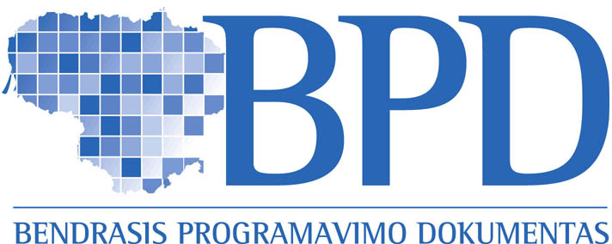 |   EUROPOS SĄJUNGA |  | 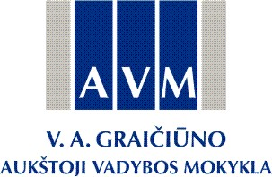

KURKIME ATEITĮ DRAUGE!

Project “Programme for logistics specialists training and assessment of competencies in the virtual learning environment “
Project No. BPD2004-ESF-2.4.0-03-05/0141
Project promoter V. A. Graičiūnas School of Management

LEARNING OPPORTUNITIES FOR LOGISTICS PRACTITIONERS FOCUSING ON ASSESSMENT OF PRIOR COMPETENCIES

Within a relatively short period Lithuania has transformed from subject based to competencies based professional education. Yet, in some areas a gap between the supply of educational opportunities and the demand of competencies still exists. One of the specific professional areas is logistics business management. Country’s geographical situation with the flow of goods east-west directions together with the national business companies needs for competent specialists make the demand of logistics specialists extremely relevant.
Taking the above into account the project “Innovative Programme for Identification, Development and Achievement Assessment of Competencies of Specialists in Logistics in e-Learning Platform” was developed and successfully implemented.
Project created several outputs which have been tested during a pilot trial: competence needs analysis performed to identify competencies necessary for specialists in logistics; toolkit for assessment of professional and key-competencies as well for the development of learner’s individual learning plan; and innovative learning programme developed for virtual learning environment. The project implemented by V. A. Graičiūnas School of Management is one of the first attempts to address the offer of learning opportunities for logistics business. Project outcomes strengthened the understanding that the development of logistics as a business sector is important for the development of both, Kaunas region and Lithuania.
On the basis of project products, the logistics specialists were offered two learning opportunities: first, a possibility to self-assess the level of logistics competencies and identify the needs for further training. Based on that, participants have individual learning programmes and take part in a blended distance learning programme.
The programme modules included Fundamentals of Logistics, Transport Logistics, Storage Logistics, Intercultural Communication, and Entrepreneurship. An innovative learning programme and learning methodology opened new opportunities for learning and career development.
The created outputs are presented to the logistics companies as the integrated competencies assessment and learning toll in Lithuania and will be further developed according to the labour market in logistics sector needs.

Further information:
Rasa Bastytė - V. A. Graičiūnas School of Management, e-mail: smc@avm.lt
Dr. Tomas Sabaliauskas - Vytautas Magnus University, e-mail: t.sabaliauskas@smf.vdu.lt

